Lab - Explore YANG Models
Name: Dawn Andrei Pamesa
Course and Section: CS0016 (NetComms 2), TS31-9
Activity: Lab Exercise 7.1 - Explore YANG Models
Date: November 10, 2026

Objectives
Part 1: Launch the DEVASC VM
Part 2: Explore a YANG Model on GitHub
Part 3: Explore a YANG Model Using pyang

Background / Scenario
YANG models define the exact structure, data types, syntax and validation rules for the content of messages exchanged between a managed device and another system communicating with the device. Working with files using the YANG language can be a bit overwhelming for the level of details in these files.
In this lab, you will learn how to use the open source pyang tool to transform YANG data models from files using the YANG language, into a much easier to read format. Using the “tree” view transformation, you will identify what the key elements of the ietf-interfaces YANG model are.

Required Resources
- 1 PC with operating system of your choice
- Virtual Box or VMWare
- DEVASC Virtual Machine

Instructions

Launch the DEVASC VM
If you have not already completed the Lab - Install the DEVASC-LAB, do so now. If you have already completed that lab, launch the DEVASC VM now.

Explore a YANG Model on GitHub
In this Part, you will install pyang module into your DEVASC VM and explore how it transforms YANG files. Pyang simplifies working with YANG files. The module comes with a pyang command line executable that transforms YANG files into a more human-readable format.

Explore Cisco IOS XE YANG models in the GitHub repository.
      - Open Chromium and navigate to https://github.com/YangModels/yang.
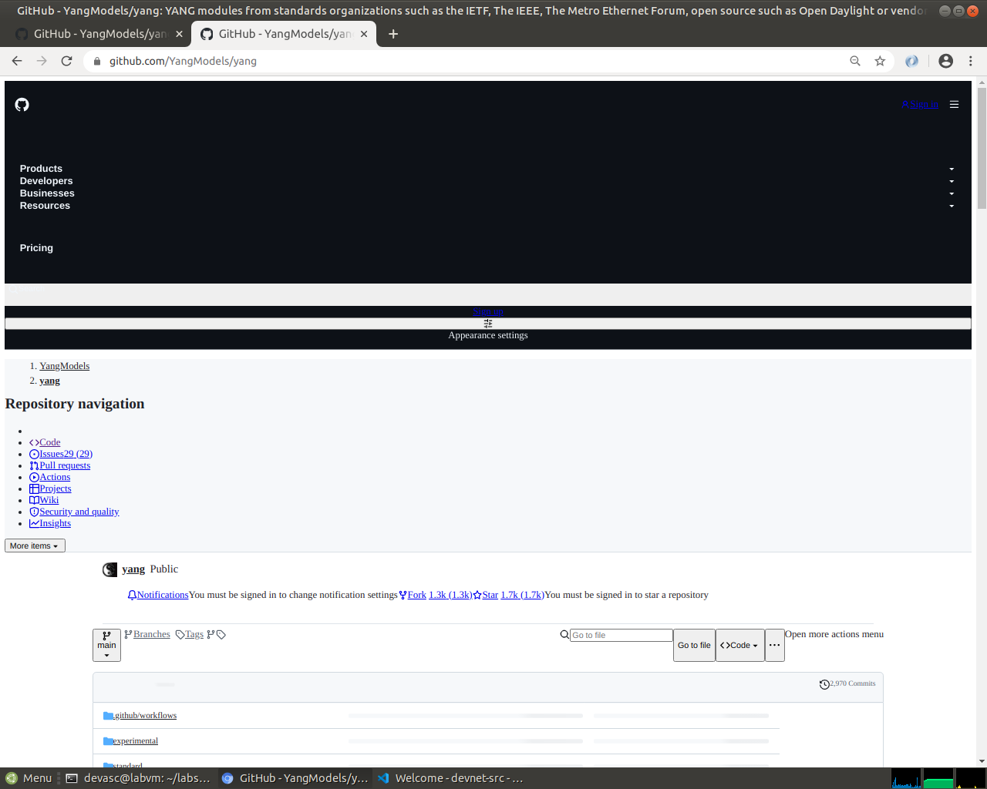
Screenshot 1: The YangModels/yang repository, opened in Chromium inside the DEVASC VM.
      - Under the master branch, navigate to the YANG models for the Cisco IOS XE version 16.9.3 by clicking the following directories: vendor > cisco > xe > 1693.
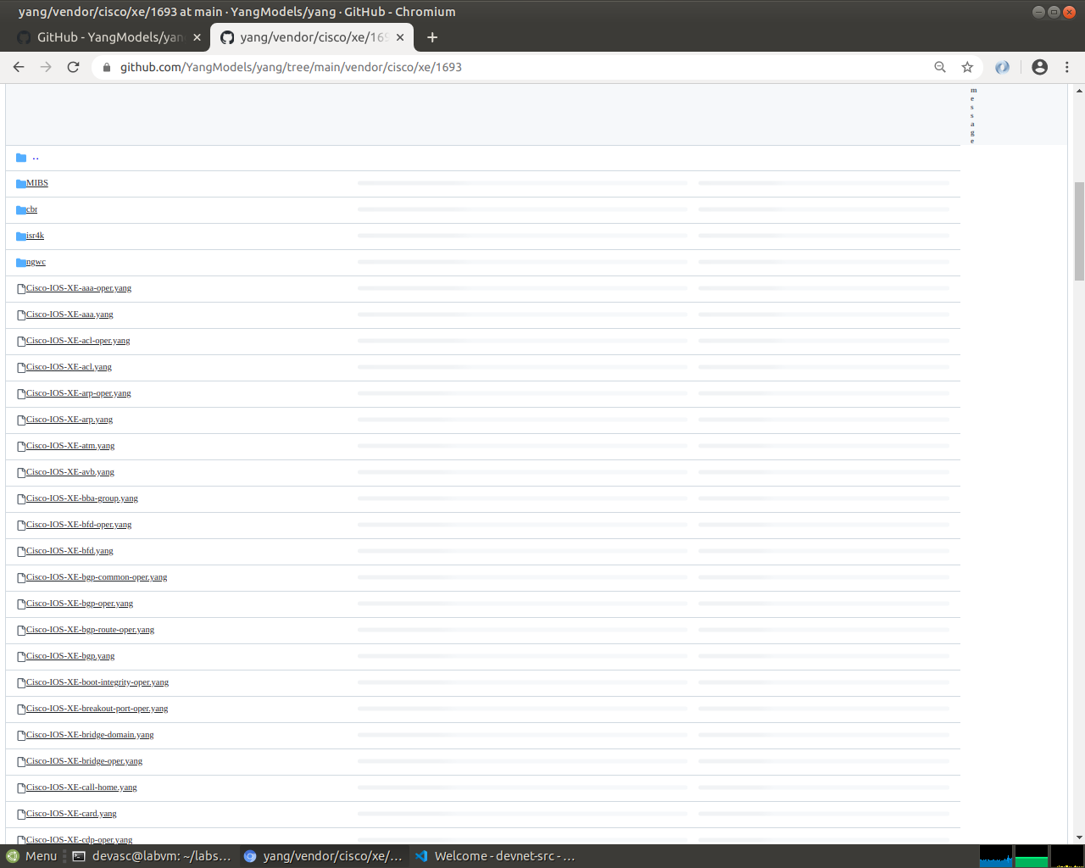
Screenshot 2: The vendor/cisco/xe/1693 folder, which holds the YANG models for Cisco IOS XE version 16.9.3.
      - Scroll down below all the Cisco YANG models and find where the IETF models begin. Look for ietf-interfaces.yang.
      - Click ietf-interfaces.yang and scroll through all the container nodes, leaf nodes, and list nodes. If you are familiar with output from the IOS command show interfaces, then you should recognize some or all of the nodes. For example, around line 221 you will see the leaf enabled.
leaf enabled {
type boolean;
default "true";
description
"This leaf contains the configured, desired state of the
interface.
Systems that implement the IF-MIB use the value of this
leaf in the 'running' datastore to set
IF-MIB.ifAdminStatus to 'up' or 'down' after an ifEntry
has been initialized, as described in RFC 2863.
Changes in this leaf in the 'running' datastore are
reflected in ifAdminStatus, but if ifAdminStatus is
changed over SNMP, this leaf is not affected.";
reference
"RFC 2863: The Interfaces Group MIB - ifAdminStatus";
}
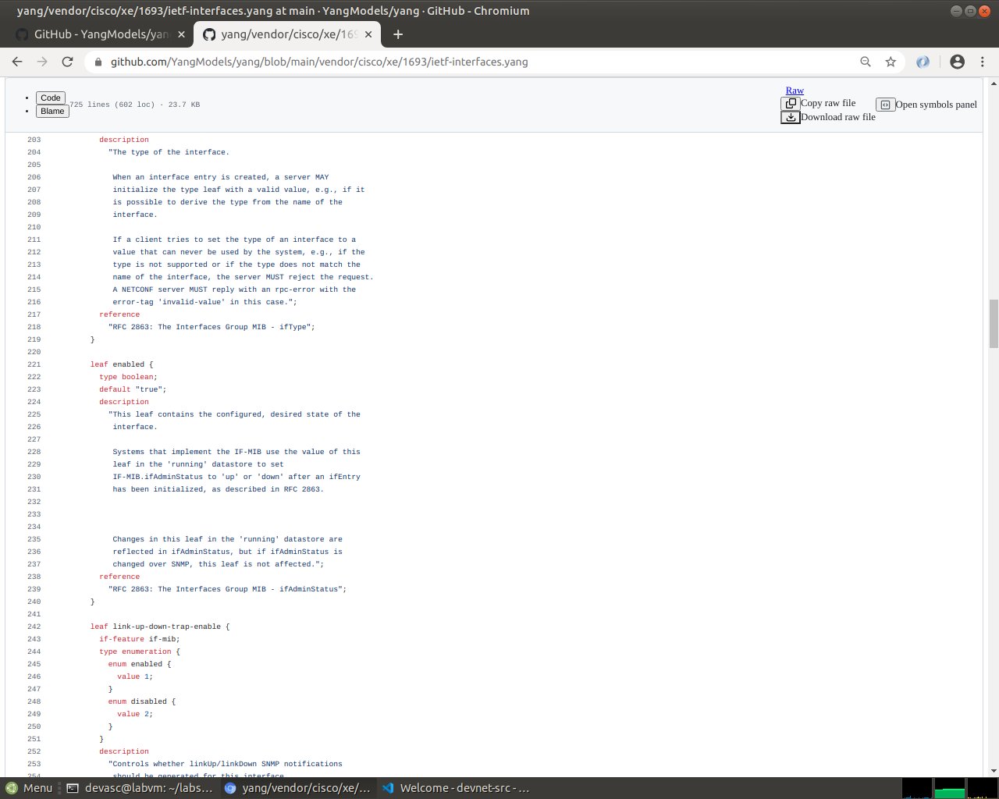
Screenshot 3: The ietf-interfaces.yang model, with leaf enabled at line 221, a boolean leaf whose default value is true.

Copy the ietf-interfaces.yang model to a folder on your VM.
      - Open VS code.
      - Click File > Open Folder... and navigate to the devnet-src directory.
      - Click OK.
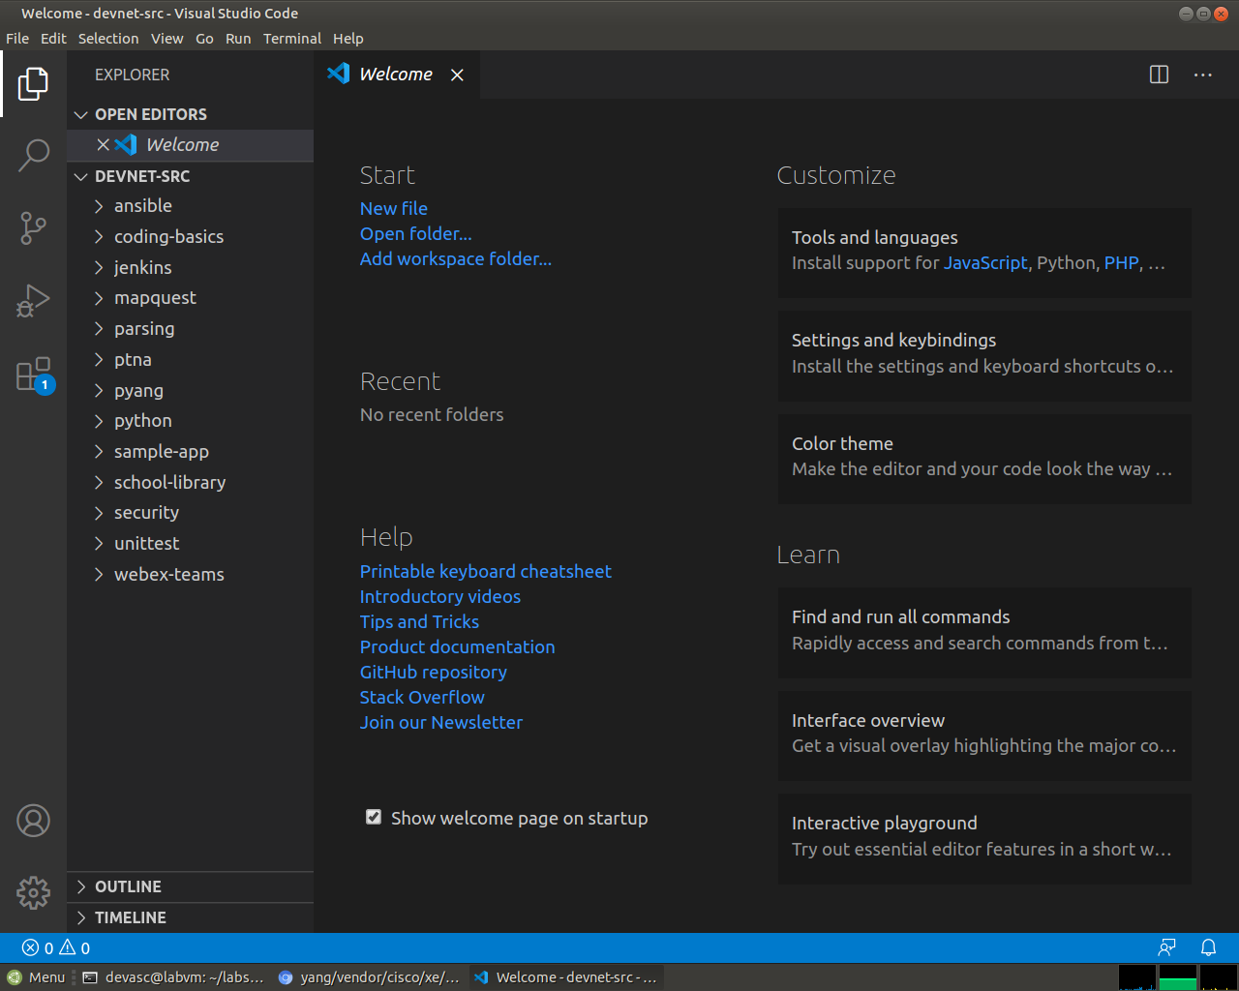
Screenshot 4: VS Code with the devnet-src folder opened, which lists all the lab folders in the Explorer pane.
      - Open a terminal window in VS Code: Terminal > New Terminal.
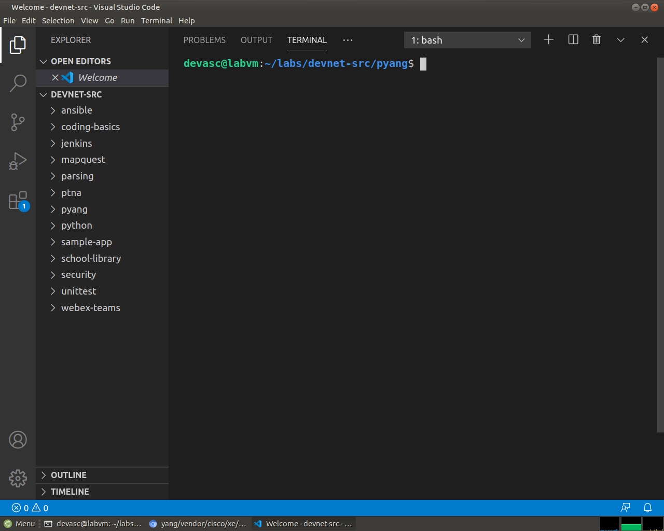
Screenshot 5: A new VS Code terminal, already inside ~/labs/devnet-src.
      - Create a subdirectory called pyang in the /devnet-src directory.
devasc@labvm:~/labs/devnet-src$ mkdir pyang
devasc@labvm:~/labs/devnet-src$
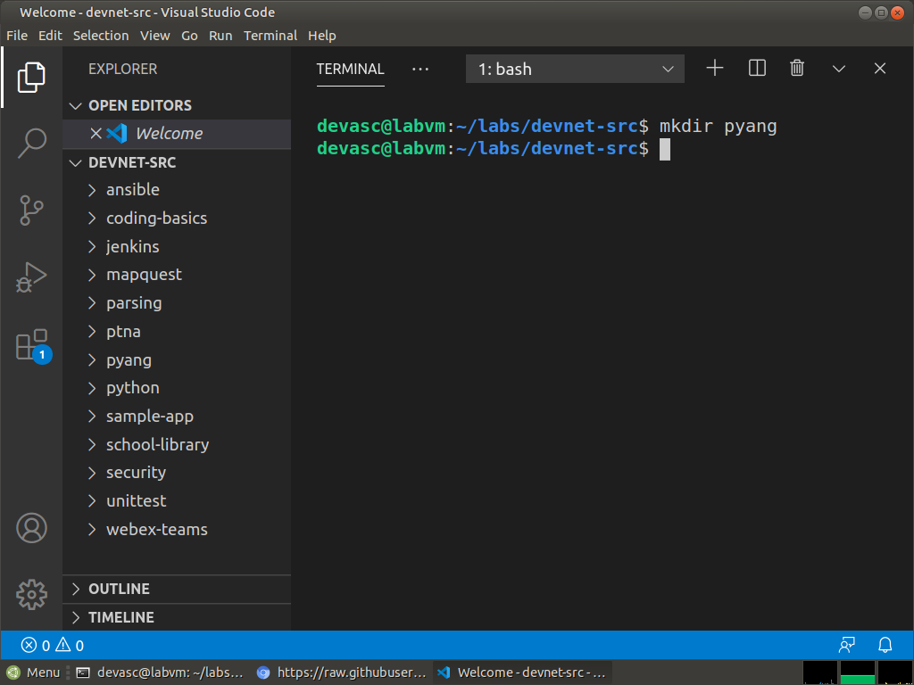
Screenshot 6: First, the pyang subdirectory was created inside devnet-src with mkdir, and it now shows in the Explorer pane.
      - Return to your Chromium tab where the ietf-interfaces.yang model is still open. Scroll back to the top, if necessary, and click Raw to display just the YANG model data.
      - Select and copy the URL.
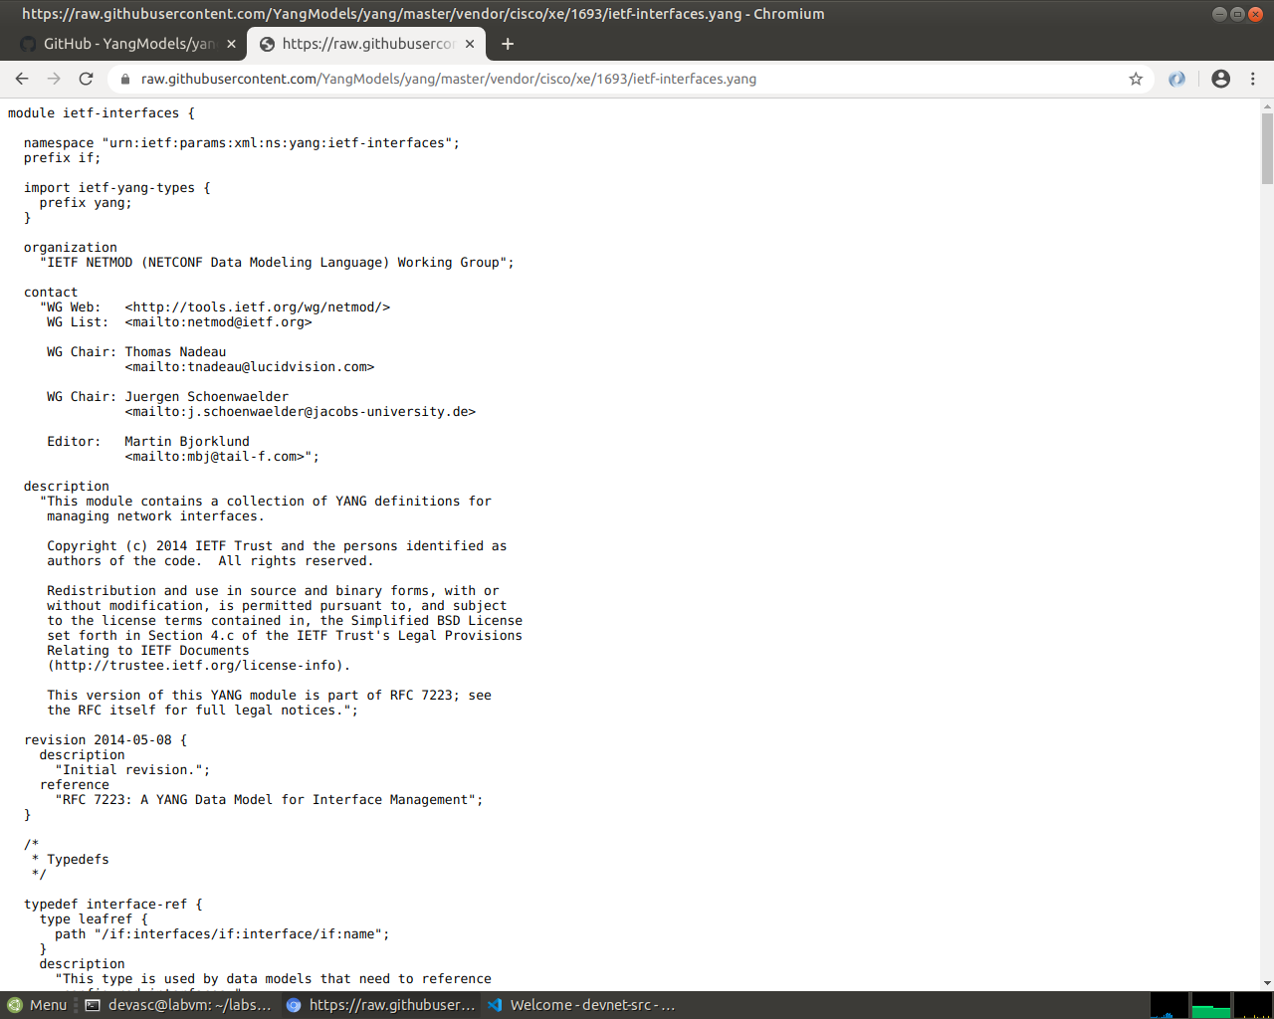
Screenshot 7: The Raw view of ietf-interfaces.yang, which gives the URL that wget needs.
      - In the terminal, go to the pyang folder.
      - Use wget to save the raw ietf-interfaces.yang file.
devasc@labvm:~/labs/devnet-src/pyang$ wget https://raw.githubusercontent.com/YangModels/yang/master/vendor/cisco/xe/1693/ietf-interfaces.yang
--2020-06-22 20:42:20-- https://raw.githubusercontent.com/YangModels/yang/master/vendor/cisco/xe/1693/ietf-interfaces.yang
Resolving raw.githubusercontent.com (raw.githubusercontent.com)... 151.101.0.133, 151.101.192.133, 151.101.128.133, ...
Connecting to raw.githubusercontent.com (raw.githubusercontent.com)|151.101.0.133|:443... connected.
HTTP request sent, awaiting response... 200 OK
Length: 24248 (24K) [text/plain]
Saving to: ‘ietf-interfaces.yang’

ietf-interfac 100% 23.68K --.-KB/s in 0.05s

2020-06-22 20:42:21 (439 KB/s) - ‘ietf-interfaces.yang’ saved [24248/24248]

devasc@labvm:~/labs/devnet-src/pyang$
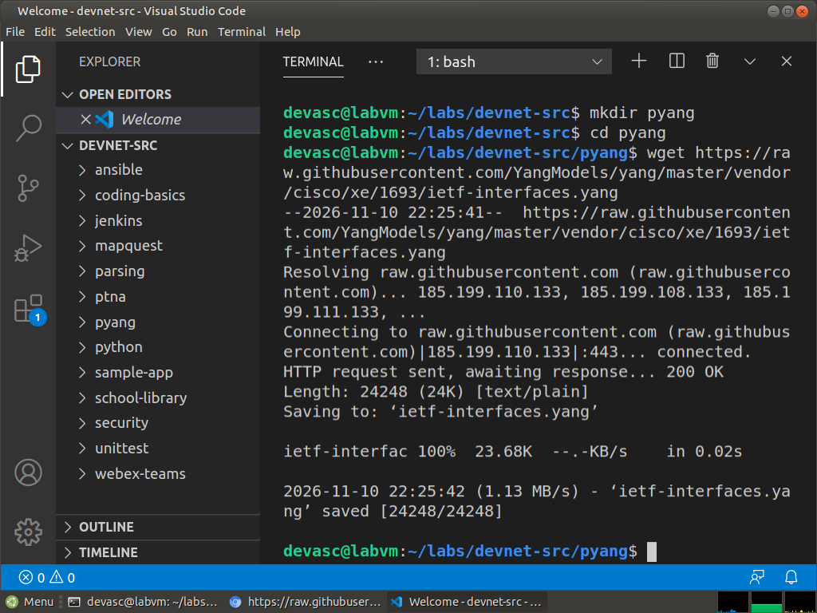
Screenshot 8: Then wget saved ietf-interfaces.yang (24248 bytes, HTTP 200 OK) into the pyang folder.
You now have a local version of the ietf-interfaces.yang model that you can manipulate with pyang.

Explore a YANG Model Using pyang
In this Part, you will install the pyang module into your DEVASC VM and explore how it transforms the YANG model you copied from GitHub. Pyang simplifies working with YANG files. The module comes with a pyang command line executable that transforms YANG files into a more human readable format.

Verify pyang is installed and up to date.
      - In VS Code, open a terminal window.
      - Verify that pyang is already installed with the pyang -v command. Your version number may be different than the one shown here. You can also
devasc@labvm:~/labs/devnet-src$ pyang -v
pyang 2.2.1
devasc@labvm:~/labs/devnet-src$
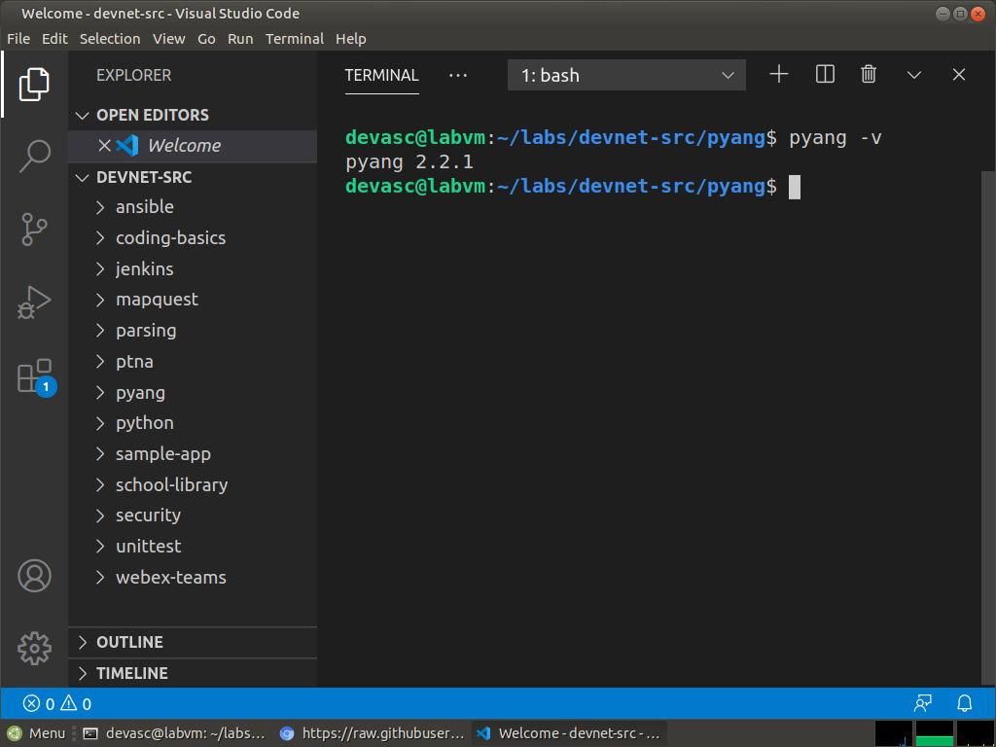
Screenshot 9: pyang is already installed in the VM, version 2.2.1.
      - (Optional) You can verify that you have the latest pyang updates using the following pip3 command. Any updates after this lab was written will be downloaded and installed.
devasc@labvm:~/labs/devnet-src$ pip3 install pyang --upgrade
Requirement already up-to-date: pyang in ./.local/lib/python3.8/site-packages (2.2.1)
Requirement already satisfied, skipping upgrade: lxml in ./.local/lib/python3.8/site-packages (from pyang) (4.5.0)
devasc@labvm:~/labs/devnet-src$
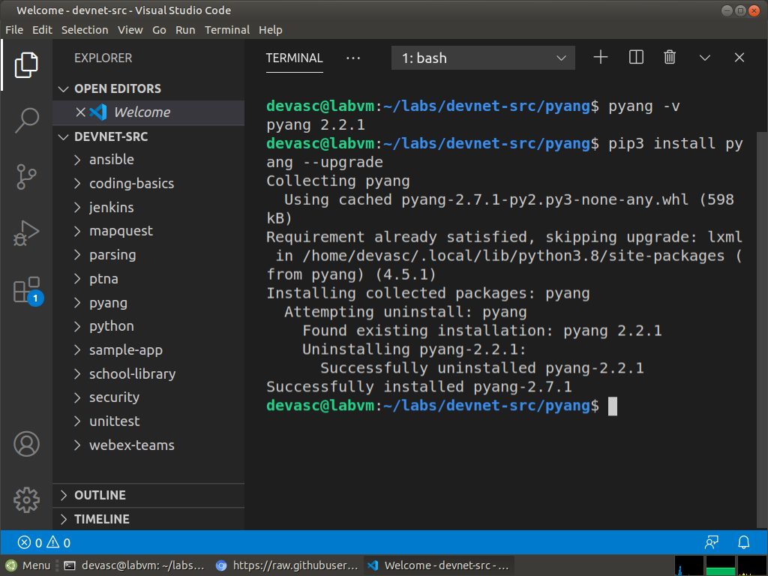
Screenshot 10: The optional upgrade replaced pyang 2.2.1 with version 2.7.1, the latest one pip found.

Transform the ietf-interfaces.yang model.
      - Navigate to the pyang directory.
devasc@labvm:~/labs/devnet-src$ cd pyang
devasc@labvm:~/labs/devnet-src/pyang$
      - Enter pyang -h | more to explore the options for transforming the YANG model. Look for the -f option as shown below. You will use the tree formatting option.
devasc@labvm:~/labs/devnet-src/pyang$ pyang -h | more
Usage: pyang [options] [<filename>...]

Validates the YANG module in <filename> (or stdin), and all its dependencies.

Options:
-h, --help Show this help message and exit
-v, --version Show version number and exit
<output omitted>
-f FORMAT, --format=FORMAT
Convert to FORMAT. Supported formats are: yang, yin,
dsdl, jstree, jsonxsl, capability, identifiers, jtox,
uml, name, omni, tree, depend, sample-xml-skeleton
<output omitted>
devasc@labvm:~/labs/devnet-src/pyang$
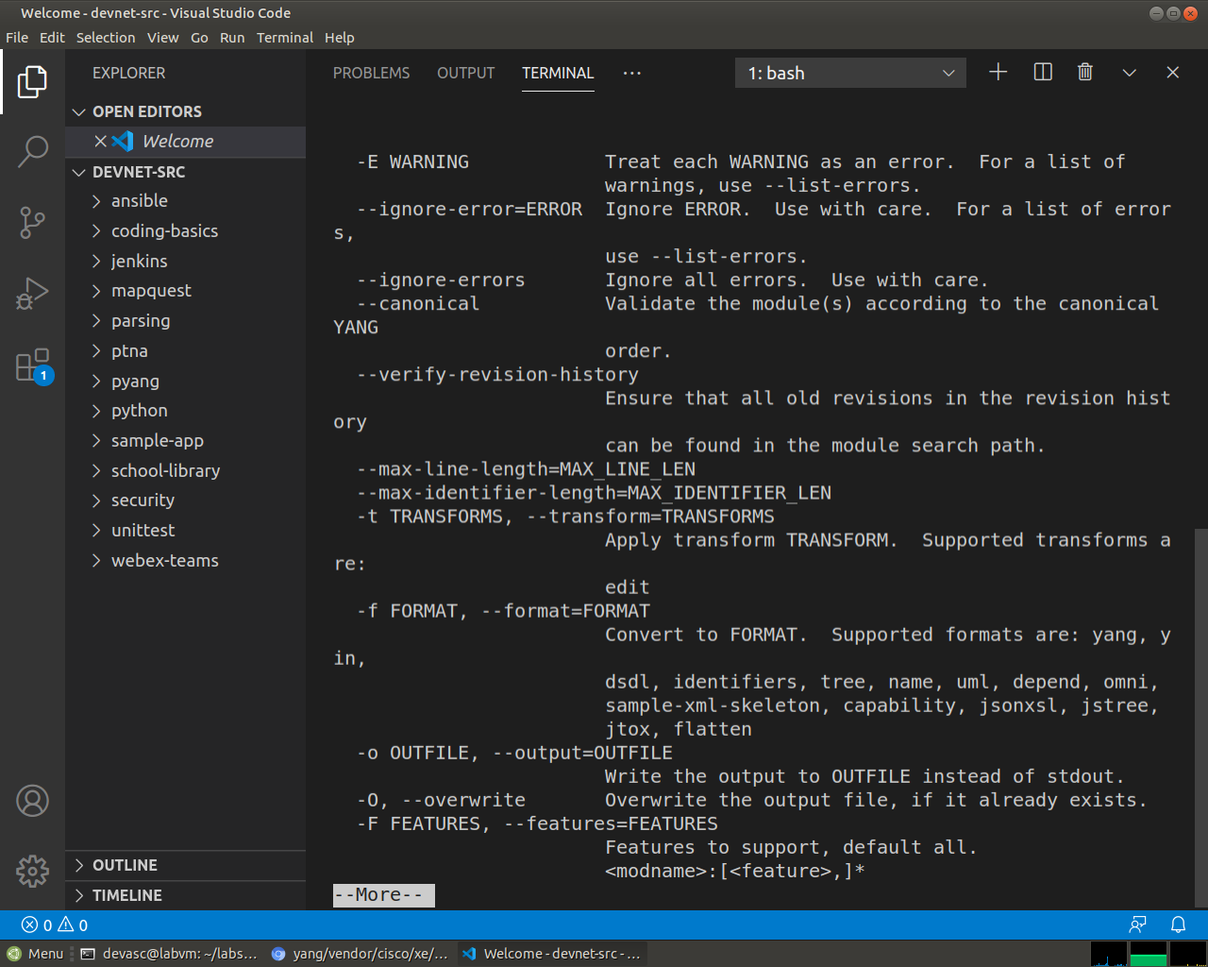
Screenshot 11: The second page of pyang -h | more, where the -f FORMAT option lists tree among the supported formats.
      - Transform the ietf-interfaces.yang model into a tree format with the following command. Notice that the leaf enabled is much easier to find and read in this format.
devasc@labvm:~/labs/devnet-src/pyang$ pyang -f tree ietf-interfaces.yang
ietf-interfaces.yang:6: error: module "ietf-yang-types" not found in search path
module: ietf-interfaces
+--rw interfaces
| +--rw interface* [name]
| +--rw name string
| +--rw description? string
| +--rw type identityref
| +--rw enabled? boolean
| +--rw link-up-down-trap-enable? enumeration {if-mib}?
+--ro interfaces-state
+--ro interface* [name]
+--ro name string
+--ro type identityref
+--ro admin-status enumeration {if-mib}?
+--ro oper-status enumeration
+--ro last-change? yang:date-and-time
+--ro if-index int32 {if-mib}?
+--ro phys-address? yang:phys-address
+--ro higher-layer-if* interface-state-ref
+--ro lower-layer-if* interface-state-ref
+--ro speed? yang:gauge64
+--ro statistics
+--ro discontinuity-time yang:date-and-time
+--ro in-octets? yang:counter64
+--ro in-unicast-pkts? yang:counter64
+--ro in-broadcast-pkts? yang:counter64
+--ro in-multicast-pkts? yang:counter64
+--ro in-discards? yang:counter32
+--ro in-errors? yang:counter32
+--ro in-unknown-protos? yang:counter32
+--ro out-octets? yang:counter64
+--ro out-unicast-pkts? yang:counter64
+--ro out-broadcast-pkts? yang:counter64
+--ro out-multicast-pkts? yang:counter64
+--ro out-discards? yang:counter32
+--ro out-errors? yang:counter32
devasc@labvm:~/labs/devnet-src/pyang$
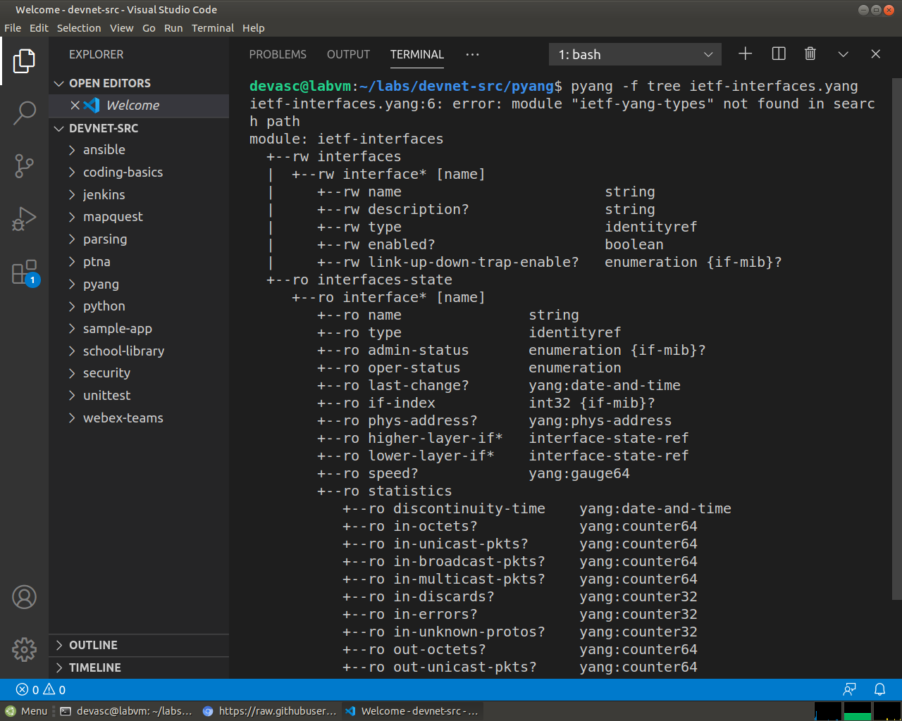
Screenshot 12: The top of the pyang -f tree output. The ietf-yang-types error appears because that module is not in the search path, yet the tree is still printed.
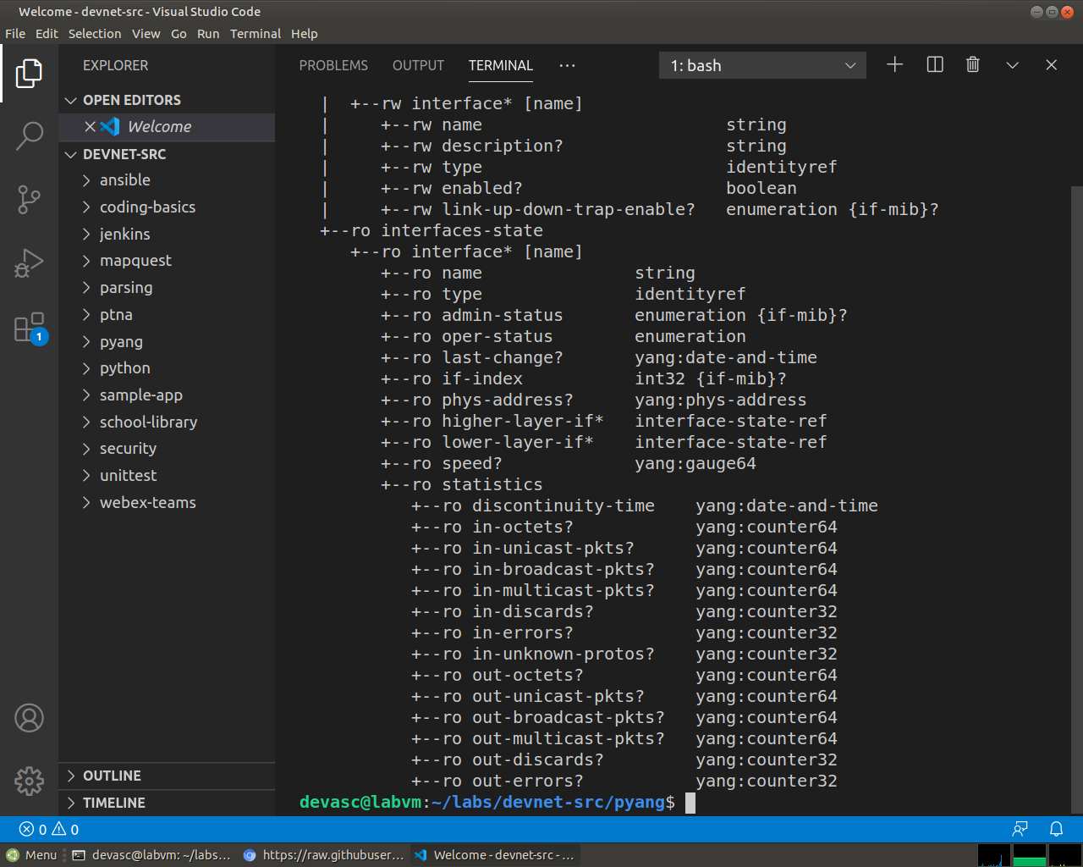
Screenshot 13: The bottom of the same tree. To conclude, leaf enabled is easy to find now, listed as rw enabled? boolean under interfaces and the read-only interfaces-state list holds the status and counters.
End of document

